**DP-SMB - NextImmune 2 - Data Science Meetings (Common Data Science Tools)**

**Assessment**

**Deadline: 31/07/2024**

To obtain the 1.0 ECTS you must fulfill the criteria of this NextImmune 2 - Data Science Meetings (Common Data Science Tools) assessment.

Prepare and submit a public GitHub repository with the completed tasks. (The link for the repository is sufficient assuming it has been made public.)

Tasks are indicated with marks to a total of 100. A mark of 50% is required to pass. In addition, a mark of 33% is needed for each task individually to pass. Upon preparation, the repository link should be sent to [Joseph.longworth@lih.lu](mailto:Joseph.longworth@lih.lu), Oliver.hunewald@lih.lu and [carole.weis@lih.lu](mailto:carole.weis@lih.lu.) (in cc). The required repository template will be provided by webex.

Please note that you will also need to have attended at least 66% (4 out of 6) of the course sessions to be able to receive the ECTS credits.

**Task 1** *(20 marks)*

1. Manage the assignment within a GitHub repository committing completed activities for Task 2,3 and 4.
2. Create a new repository from the provided template repository to your own GitHub account.

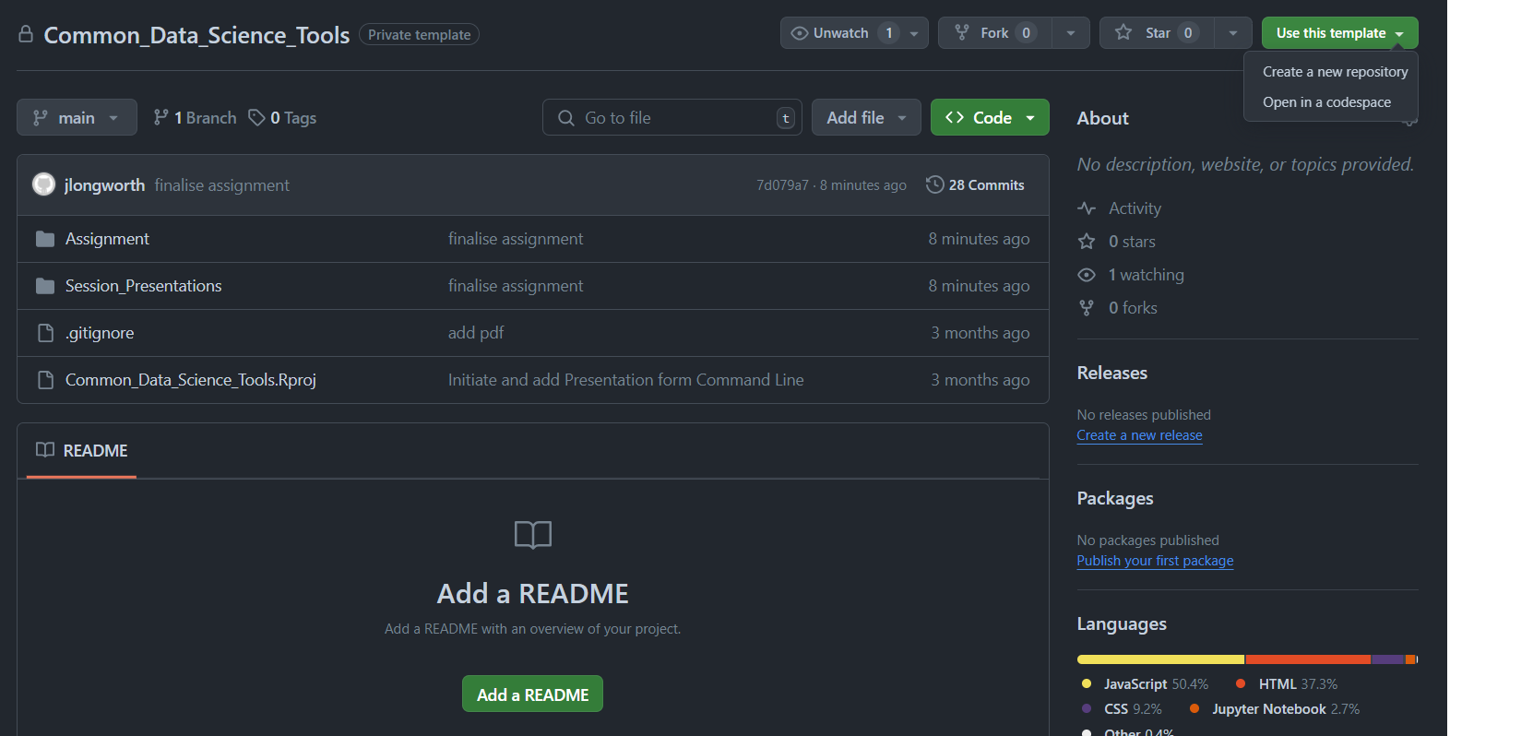

1. Ensure the repository is set as public for the submission.
   1. Repositories should have at least 3 commit with clear comments.
   2. Repositories should have at least 2 branches.
   3. A sensible ReadMe should be included.

**Task 2** (40 marks)

1. For the completion of the task and further instructions open the *.ipynb in a local python environment or remote such as google colab.
2. Complete the provided python notebook using the data also provided.

**Task 3** (20 marks)

1. Prepare a shiny web application using your own data.
   1. Applications should have at least 3 inputs to control the presentation of the data.
   2. Marks will be awarded for improved styling

**Task 4** (20 marks)

Within the repository, there is a folder Inkscape. A figure is provided with some panels to be added

1. Clip to the view boxes the cellular image B and align with labels to a grid.
2. Clip, arrange and label the protein digestion gel image.
3. For panels D-F using the scientific extension adjust the text to arial, 8pt, with 0.2 mm stroke widths and black strokes (not for text)
4. Change the text colour of panel E to black
5. Adjust panel F so the x axis is 20 mm as is currently for panel D & E.
6. Insert as a penultimate panel a graphic produced by the shiny application. (can be a raster image)
7. Insert as a final panel the heatmap graphic produced by the python notebook. (can be a raster image)
8. Align graphics
9. Utilizing the Scientific extension run flattener and homogenizer to fix text abnormalities whilst setting the text to 8pt
10. Export the prepared figure as a pdf and png
11. Processed files should be pushed back to the git repository.